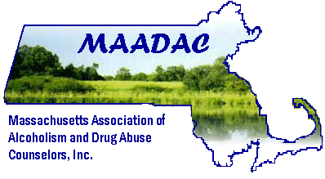MAADAC Scholarship Application (MAADAC Members Only)
(All scholarship applications must be received at least 45 days prior to scheduled date of training)
__________________________________________________________
Please list the training event you would like to attend:____________________________________
Name:___________________________________________________________________________
Mailing Address: City, State, Zip______________________________________________________
Daytime phone:_______________________________Email:_______________________________
1. Please list the amount you are requesting; for what expenses; and the amount you/others will be contributing if any (registration, accommodation, travel etc.) ENCLOSE A COPY OF THE TRAINING FLYER/BROCHURE.

2. Please explain your expectations for this training event.

3. Is there any other information you’d like to share with us?

ALL SCHOLARSHIP FUNDS WILL BE PAID DIRECTLY TO THE APPLICANT UPON MAADC’S RECEIPT OF YOUR CERTIFICATE OF ATTENDANCE. IN OTHER WORDS, YOU NEED TO PAY UP FRONT AND WE WILL REIMBURSE YOU – IF APPROVED. APPROVAL WILL BE PRIOR TO THE EVENT, APPROXIMATELY 2-3 WEEKS AFTER REQUEST FOR SCHOLARSHIP. ONLINE TRAININGS WILL only BE CONSIDERED DURING THIS COVID-19 PERIOD OF TIME. TRAININGS MUST BE PRE-APPROVED BY MBSACC (CERTIFICATION BOARD) AND/OR BY ADCARE EDUCATIONAL INSTITUTE. Approval will be considered for one training per calendar year. The maximum allowance per training is $200.

Please return to: Linda Mullis Email: cadaclm@cox.net
Phone: 413-330-9828

Approved by: ________________________Date: ___________________Approved Amount:___________________ Date Received Attendance Report: ___________________ Date sent check to individual:____________________

